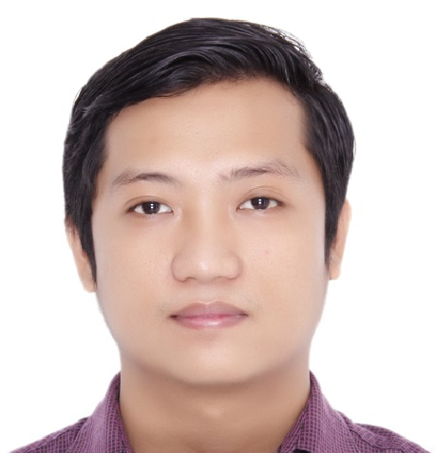
CURRICULUM VITAE

Expectd salary : 5k+

JAY-R SONICO PAGUIRIGAN, CPA
Address : Abu Dhabi City, United Arab Emirates
Contact No : +971566915882
Visa Status : Long-term Visit Visa until June 26, 2015
Nationality : Filipino
Email Address : paguiriganjayr@yahoo.com

POSITIONS APPLIED FOR:
Accountant, Auditor, Financial Analyst, Budget Analyst, or any
accounting/finance related jobs

CAREER OBJECTIVE:

- To work in a company where I can contribute and effectively apply and utilize my knowledge, skills and inherent potentials for the attainment of its goals; and

- To assume responsibility for the position given with professional competence and to perform task with due care and diligence.

PROFESSIONAL QUALIFICATION:

- CERTIFIED PUBLIC ACCOUNTANT
Professional Regulation Commission - Philippines
October, 2010

- CAREER SERVICE PROFESSIONAL
Civil Service Commission - Philippines
July, 2009

WORK EXPERIENCE:

Budget and Management Specialist
Budget and Management Bureau - F
Department of Budget and Management/Government of the Philippines
Manila, Philippines
February 17, 2014 to March 20, 2015

Budget and Management Analyst
Budget and Management Bureau - F
Department of Budget and Management/Government of the Philippines
Manila, Philippines
August 4, 2011 to February 17, 2014

Duties and responsibilities:

- Evaluates/analyzes the annual Corporate Operating Budgets submitted by Government Owned and/or Controlled Corporations (GOCCs);
- Evaluates and recommends the level of budgetary and funding requirements of GOCCs;
- Analyzes/evaluates budgetary requirements of GOCCs as input on the annual budget preparation process/stage;
- Processes agency requests pertaining to organization, staffing, compensation and physical resources;
- Prepares correspondence and replies to queries pertaining to funding, organizational modifications, position classification and compensation matters; and
- Maintains records of accounts and releases, and reviews of agency accountability reports.

Associate Auditor
Mateo, Ramos, Celestino, Llona, and Co. CPAs
Makati City, Philippines
January 24, 2011 to July 24, 2011

Duties and responsibilities:

- Performs reviews on company’s transactions through vouching, tracing and making analytical procedures;

- Performs audit techniques and procedures on accounts;

- Preparation of schedules and analysis of accounts as needed by the audit program;

- Prepares audit report, complete set of financial statements, proposed audit adjustments, income tax return and other reports required by the engagement;

- Preparation of government taxation forms and government remittances; and

- Prepares monthly bank reconciliation.

EDUCATIONAL BACKGROUND:

Course : Bachelor of Science in Accountancy
Saint Ferdinand College
Isabela, Philippines
March 26, 2010

SKILLS:

- Has experience in government administration and budgeting for Government Agencies;

- Has a basic knowledge in International Accounting Standards and IFRS;

- Can be able to prepare and review complete set of financial statements;

- Has been able to develop analytical skills and decision making (e.g. financial analysis and etc.)

- Can easily learn and adapt to accounting systems/softwares;

- Computer literate (e.g. MS Word, MS Excel, MS Power Point, and etc.);

- Has a good writing and effective communication skills; and

- Has the ability to adapt in changing environment, can be easily trained and can work under pressure both in a team or independently.

SEMINARS/TRAININGS ATTENDED:

Telephone Etiquette and Unified Accounts Code Structure Application Course Help Desk Implementation Training Program by Department of Budget and Management – January 7 to 8, 2015

Unified Accounts Code Structure Application Course by Australian Department of Foreign Affairs and Trade - March 26 to 28, 2014

Training on Project Appraisal by National Economic and Development Authority - April 15 to 17, 2013

Bottom-Up Planning and Budgeting by the Philippine Association for Government Budget Administration - August 15-18, 2012

PERSONAL DATA:

Date of Birth : May 17, 1990
Place of Birth : Lagawe, Ifugao, Philippines
Civil Status : Single
Religion : Roman Catholic
Sex : Male

CHARACTER REFERENCE:

Mr. Teodoro T. Terrenal
Department of Budget and Management – Manila, Philippines
Contact No. +639998867991

Ms. Sheila Marie Cua
Joseph Group - UAE
Contact No. 0502464015

Ms. Vanessa Gamanos, CPA
Commission on Audit – Manila, Philippines
Contact No. +639261165803

